Xamarin Equations App

Guidelines

08.04.2019

Cracow University of Technology

Urszula Lis & Piotr Makowiec

Table of Contents

Introduction 2

Installation 2

How to use the application 4

# Introduction

This application has been made for “Application programming for mobile devices” classes at the Cracow University of Technology.

Our goal was to build “Xamarin.Forms” application which could solve three, not trivial equations.

To build this application we used Visual Studio 2019 and C# language.  
We also used the MVVM design pattern to separate models, logic, and views, to make our project more readable, extendable and flexible.

Our application is working on such platforms as:

* Android
* Windows 10
* iOS

# Installation

First of all, when you clone the repository and open the project in Visual Studio, you need to restore packages, to make sure all the libraries which were used you’ve got on your desktop. To make it, click the right mouse button on the project file and click “Restore NuGet Packages”.

A screenshot of a video game

Description generated with high confidence

This project contains Xamarin Telerik controls, so to make it work, you need to have Trial Account on their website or full subscription. How to do that, perfectly is shown here: <https://docs.telerik.com/devtools/xamarin/getting-started>

When it’s done, all you need is to choose what platform our app should be launched. To do that, press the right mouse button on one of the projects: Android, iOS or UWP and click: “Set as Startup Project”.

A screenshot of a computer screen

Description generated with very high confidence

Then on the top of Visual Studio, press button with a green arrow, to start the application on the chosen platform.

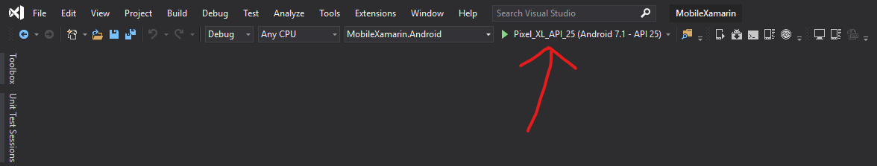

That’s it, now the application is running.

# How to use the application